“Inventory and Warehouse Management System”
A Project Report Submitted in the partial fulfillment of the requirements for the award of the degree of
BACHELOR OF TECHNOLOGY
In
DEPARTMENT OF COMPUTER SCIENCE AND INFORMATION TECHNOLOGY
By
M. Laasya Sri 2520090196
M. Rajini 2520090197
K. Ramya 2520090313
Section 12 Team 17 CS-IT
Under the Esteemed Guidance of
Dr. Kaja Shareef
Head of Department
Department of Computer Science and Information Technology



K L (Deemed to be) University
DEPARTMENT OF COMPUTER SCIENCE AND INFORMATION TECHNOLOGY

Declaration
The Project Report entitled “Inventory and Warehouse Management System” is a record of bonafide work of M. Laasya Sri - 2520090196, M. Rajini - 2520090197 and K. Ramya - 2520090313 submitted in partial fulfillment of the requirements of the course DATABASE SYSTEMS ENGINEERING AND DISTRIBUTED BACKEND DEVELOPMENT (25CS1302E), Section 12, Team 17, during 2026-2027, Trimester 4, at KLH University. The results embodied in this report have not been copied from any other student, department, or institution.

M. Laasya Sri - 2520090196
M. Rajini - 2520090197
K. Ramya - 2520090313

K L (Deemed to be) University
DEPARTMENT OF COMPUTER SCIENCE AND INFORMATION TECHNOLOGY

CERTIFICATE
This is to certify that the project report entitled “Inventory and Warehouse Management System” is a bonafide work done and submitted by M. Laasya Sri - 2520090196, M. Rajini - 2520090197 and K. Ramya - 2520090313 in partial fulfillment of the requirements of the course DATABASE SYSTEMS ENGINEERING AND DISTRIBUTED BACKEND DEVELOPMENT (25CS1302E), Section 12, Team 17, at KLH University during 2026-2027, Trimester 4.

Signature of the Guide
Signature of the Course Coordinator Signature of the HOD

ACKNOWLEDGEMENT
The success of this project would not have been possible without the timely help and guidance rendered by many people. We wish to express our sincere thanks to all those who assisted us in one way or the other in completing this project.
We express our gratitude to Dr. Kaja Shareef, Head of the Department of Computer Science and Information Technology, for providing us with adequate facilities, ways and means by which we were able to complete this project-based lab.
Our greatest appreciation goes to our Course Coordinator and project guide, [Guide Name], Department of Computer Science and Information Technology, for their support, encouragement and guidance throughout this project.
We thank all the members of the teaching and non-teaching staff who assisted us directly or indirectly in the successful completion of this project. Finally, we sincerely thank our parents, friends and classmates for their kind help and cooperation during our work.

M. Laasya Sri - 2520090196
M. Rajini - 2520090197
K. Ramya - 2520090313

Abstract
The Inventory and Warehouse Management System is a web-based application designed to efficiently manage products, warehouses, suppliers, staff, stock transactions and orders through a centralized platform. Manual stock registers, scattered spreadsheets and unclear storage locations lead to stock mismatches, wasted warehouse space and slow product retrieval. The system provides a secure and organized environment for monitoring inventory, tracking stock movement, managing warehouse capacity and viewing the products stored in each warehouse.
The proposed system offers a responsive interface for secure login, product and supplier management, warehouse and storage-location management, stock-in, stock-out and transfer transactions, order handling, barcode-based product lookup and dashboard charts. Authentication and role-based access control protect the system, so that each user can reach only the functions that belong to their role.
The system also focuses on improving warehouse efficiency through Warehouse Slotting Optimization. DSA techniques such as sorting, priority queues and greedy algorithms are used to prioritize products based on demand and assign them to suitable warehouse locations, considering storage capacity, product requirements and accessibility. This improves inventory visibility, utilizes warehouse space efficiently and reduces the time and distance required for product retrieval.
The application uses React.js with Chart.js for the frontend, Node.js and Express.js for the backend, and MySQL for storing related records. The documented database has eleven tables covering users, staff, warehouses, storage locations, categories, suppliers, products, inventory, stock transactions, orders and order items. Transactions and row locks support consistent stock updates, and JWT secures protected requests. This report describes the planned design and features of the project; execution outcomes must be confirmed during the project demonstration.

Index
S.No. | Chapters | Topics | Page No.
 | Acknowledgement |  | 4
 | Abstract |  | 5
1 | Introduction | 1.1 Background of the Project  1.2 Problem Statement  1.3 Scope of the Project  1.4 Objectives  1.5 Importance of the Application  1.6 Target Users / Audience | 7
2 | System Requirements | 2.1 Hardware Requirements  2.2 Software Requirements  2.3 Development Tools and Frameworks | 9
3 | Technology Stack | 3.1 Frontend  3.2 Backend  3.3 Database  3.4 Version Control  3.5 Authentication and Security Libraries | 10
4 | System Architecture | 4.1 High-Level Architecture Diagram  4.2 Description of Each Layer  4.3 Deployment Architecture | 11
5 | Design | 5.1 Database Design Principles  5.2 ER Diagram / Database Schema  5.3 Design Decisions and Assumptions | 12
6 | Implementation | 6.1 Module-wise Implementation  6.2 Front-end Logic  6.3 API Integration  6.4 Authentication and Authorization | 14
7 | Features | 7.1 List of Main Features  7.2 How Each Feature Works | 16
8 | Testing | 8.1 Postman API Testing  8.2 Integration Testing  8.3 Tools Used for Testing  8.4 Test Cases and Results | 17
9 | Deployment | 9.1 Steps to Deploy  9.2 Environment Configuration  9.3 Hosting of Frontend and Backend | 18
10 | Challenges & Limitations | 10.1 Issues Faced During Development  10.2 Solutions Applied  10.3 Current Limitations or Known Bugs | 19
11 | Future Enhancements | 11.1 Planned Features  11.2 Possible Integrations or Optimizations | 20
12 | Conclusion | 12.1 Summary of the Project  12.2 What Was Achieved  12.3 Skills Learned | 21
13 | References | Documentation, tools, and resources used | 22
14 | Appendices | Sample Code Snippets  Installation / Setup Instructions  Default Login Credentials  API Reference Summary  Screenshots (to be added by the student) | 23

CHAPTER 1: INTRODUCTION

1.1 Background of the Project
Warehouses hold the stock on which retail, manufacturing and distribution businesses depend. In many small and medium warehouses, stock is still tracked in paper registers or separate spreadsheets, supplier details are kept elsewhere, and the physical location of a product is known only to the staff who placed it. As the number of products, suppliers and orders grows, stock counts drift from reality, products are stored in awkward locations and staff spend extra time walking to find items.
The Inventory and Warehouse Management System brings products, warehouses, suppliers, staff, stock transactions and orders into one database-backed web application. Authorized users can see what is stored in each warehouse, record every stock movement and view summaries on a dashboard. A Warehouse Slotting Optimization module suggests where products should be stored so that frequently requested items are easy to reach.

1.2 Problem Statement
The project addresses the difficulty of managing products, warehouse space, suppliers, stock movement and customer orders through disconnected manual processes. The system must keep stock quantities accurate, stop stock from being issued when it is not available, respect the capacity of each storage location, protect data with role-based access, and help the warehouse place fast-moving products where they can be retrieved with the least time and distance.

1.3 Scope of the Project
The scope includes secure login with role-based access, management of products, categories, suppliers, warehouses, storage locations and staff, recording of stock-in, stock-out, transfer and adjustment transactions, order creation and tracking, barcode-based product lookup, dashboard charts and Warehouse Slotting Optimization. React, Express and MySQL form the planned web implementation. Hardware integrations such as RFID readers or automated storage systems, and a dedicated native mobile application, are outside the current scope.

1.4 Objectives
- Maintain a central, accurate record of products, suppliers, warehouses and storage locations.
- Track every stock movement (stock-in, stock-out, transfer, adjustment) so that quantities can be traced and audited.
- Monitor warehouse capacity and show the products stored in each warehouse and location.
- Keep stock updates consistent through database transactions, validation and constraints, so that stock never becomes negative or exceeds location capacity.
- Secure the system with JWT authentication and role-based access control.
- Apply sorting, priority queues and greedy algorithms to assign high-demand products to accessible, suitable locations.
- Provide dashboard charts and barcode lookup that help staff and managers act quickly.

1.5 Importance of the Application
By centralizing inventory data, the application reduces manual record keeping and improves visibility of stock levels. Managers can see low-stock products and warehouse utilization at a glance, staff can look up a product by scanning its barcode, and the slotting module reduces unnecessary travel inside the warehouse. A transaction history gives accountability for every change to stock.

1.6 Target Users / Audience
The system serves warehouse administrators, warehouse managers and warehouse staff. Administrators manage users, warehouses and master data. Managers monitor stock, orders and reports and run slotting optimization. Staff record stock movements, scan products and fulfil orders for the warehouse they are assigned to.

CHAPTER 2: SYSTEM REQUIREMENTS

2.1 Hardware Requirements
A development computer with a dual-core processor, at least 4 GB of RAM and sufficient free storage for Node.js dependencies, MySQL and the project files can run the application locally. An 8 GB RAM system provides a more comfortable development environment. Users need a modern browser on a computer, tablet or phone. Barcode lookup requires a camera-enabled device or a USB barcode scanner; products can also be found by typing the barcode or SKU manually.

2.2 Software Requirements
- Node.js 18 or later, with npm
- MySQL 8.0 or later
- A modern web browser (Chrome, Edge or Firefox)
- Git, for version control
- MySQL Workbench and Visual Studio Code for development (optional but recommended)
- Postman, for API testing

2.3 Development Tools and Frameworks
React.js supports the frontend and Chart.js draws dashboard charts. Node.js and Express.js provide the REST API. MySQL stores relational data through the mysql2/promise driver. JWT supports authentication, and a barcode scanner API supplies camera-based barcode reading in the browser. VS Code and MySQL Workbench are used for development; Postman supports API validation.

CHAPTER 3: TECHNOLOGY STACK

3.1 Frontend
The frontend uses React.js with reusable components for the dashboard, product tables, warehouse views, stock-transaction forms and order screens. Chart.js renders charts such as stock by category, warehouse utilization and monthly stock movement. The barcode scanner API is used on the scan screen to read a product code from the device camera. Responsive styling allows the same interface to be used on computers and tablets.

3.2 Backend
The Node.js and Express.js backend exposes REST endpoints for authentication, products, suppliers, warehouses, locations, inventory, stock transactions, orders, barcode lookup, reports and slotting. Routes receive requests, middleware validates the token and role, and controller or service logic applies business rules. The mysql2/promise connection pool provides database access and supports multi-step transactions.

3.3 Database
The inventory_management MySQL database contains eleven related tables: users, staff, warehouses, locations, categories, suppliers, products, inventory, stock_transactions, orders and order_items. Primary keys identify records and foreign keys link related data. Unique constraints on email, SKU and barcode prevent duplicates, and CHECK constraints stop negative quantities and invalid capacities.

3.4 Version Control
Git and GitHub are used to track frontend, backend and database changes in a shared project repository. Environment secrets are kept outside source control.

3.5 Authentication and Security Libraries
JSON Web Tokens (jsonwebtoken) secure protected requests. Passwords are stored as salted hashes using bcryptjs rather than as plain text. Protected routes verify the token and the user’s role before running. Only administrators can create manager and staff accounts, and all database queries use parameters to avoid SQL injection.

CHAPTER 4: SYSTEM ARCHITECTURE

4.1 High-Level Architecture Diagram
The system follows a standard three-tier architecture that separates the user interface, the business logic and the persisted data. Figure 4.1 shows the three layers and how a request flows between them.
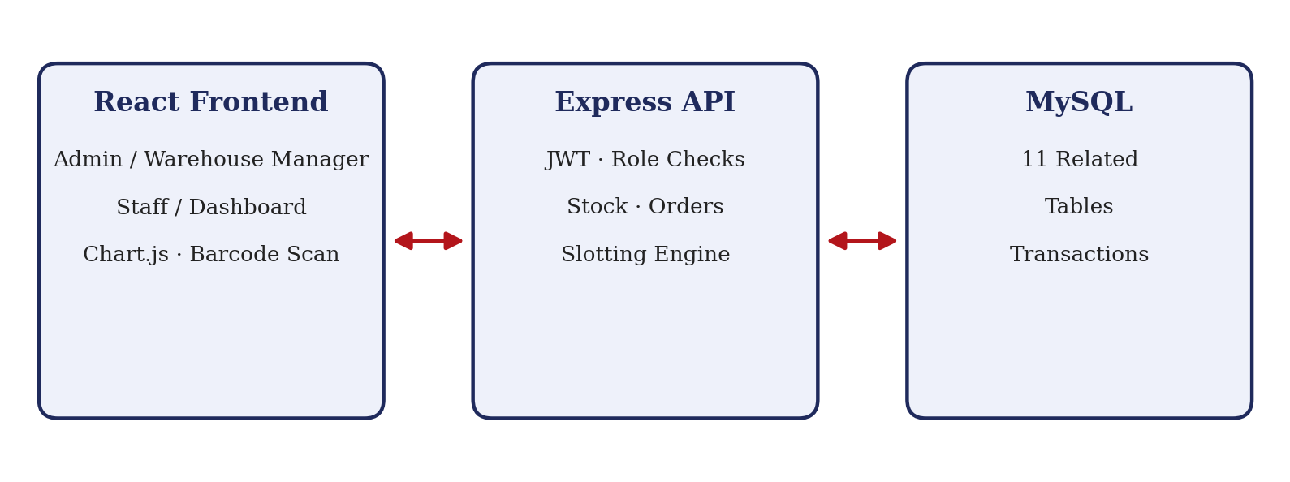
Figure 4.1: Inventory and Warehouse Management three-tier architecture

4.2 Description of Each Layer
The Presentation Layer is the React single-page application. It never talks to MySQL directly; every piece of data it shows comes from calling the REST API over HTTP.
The Application Layer is the Express REST API. It validates authentication and roles, checks product and stock availability, enforces location capacity, records stock transactions and runs the slotting algorithm. Database transactions connect related updates so that a failed operation does not leave partial data behind.
The Data Layer is the MySQL database, accessed through a connection pool rather than a single long-lived connection, so multiple requests can be served concurrently without waiting on each other unnecessarily.

4.3 Deployment Architecture
For local development, the Express backend is planned to listen on port 5000, the React frontend on port 5173 and MySQL on port 3306. The frontend sends API requests to the backend rather than connecting directly to the database. A hosted deployment would add HTTPS, managed secrets, a production database and monitoring.

CHAPTER 5: DESIGN

5.1 Database Design Principles
The schema is normalized to remove redundant data: each fact is stored in exactly one place, and every relationship between entities is expressed through a foreign key rather than by duplicating data across tables. Every table enforces its own invariants directly in the database, using PRIMARY KEY, FOREIGN KEY, UNIQUE and CHECK constraints, so that invalid data (a negative quantity, a duplicate SKU, a location with zero capacity) is rejected at the database level even if a bug elsewhere in the application tried to insert it.

5.2 ER Diagram / Database Schema
The database contains eleven related tables; Figure 5.1 shows the main relationships and Table 5.1 summarizes each table and its key fields.
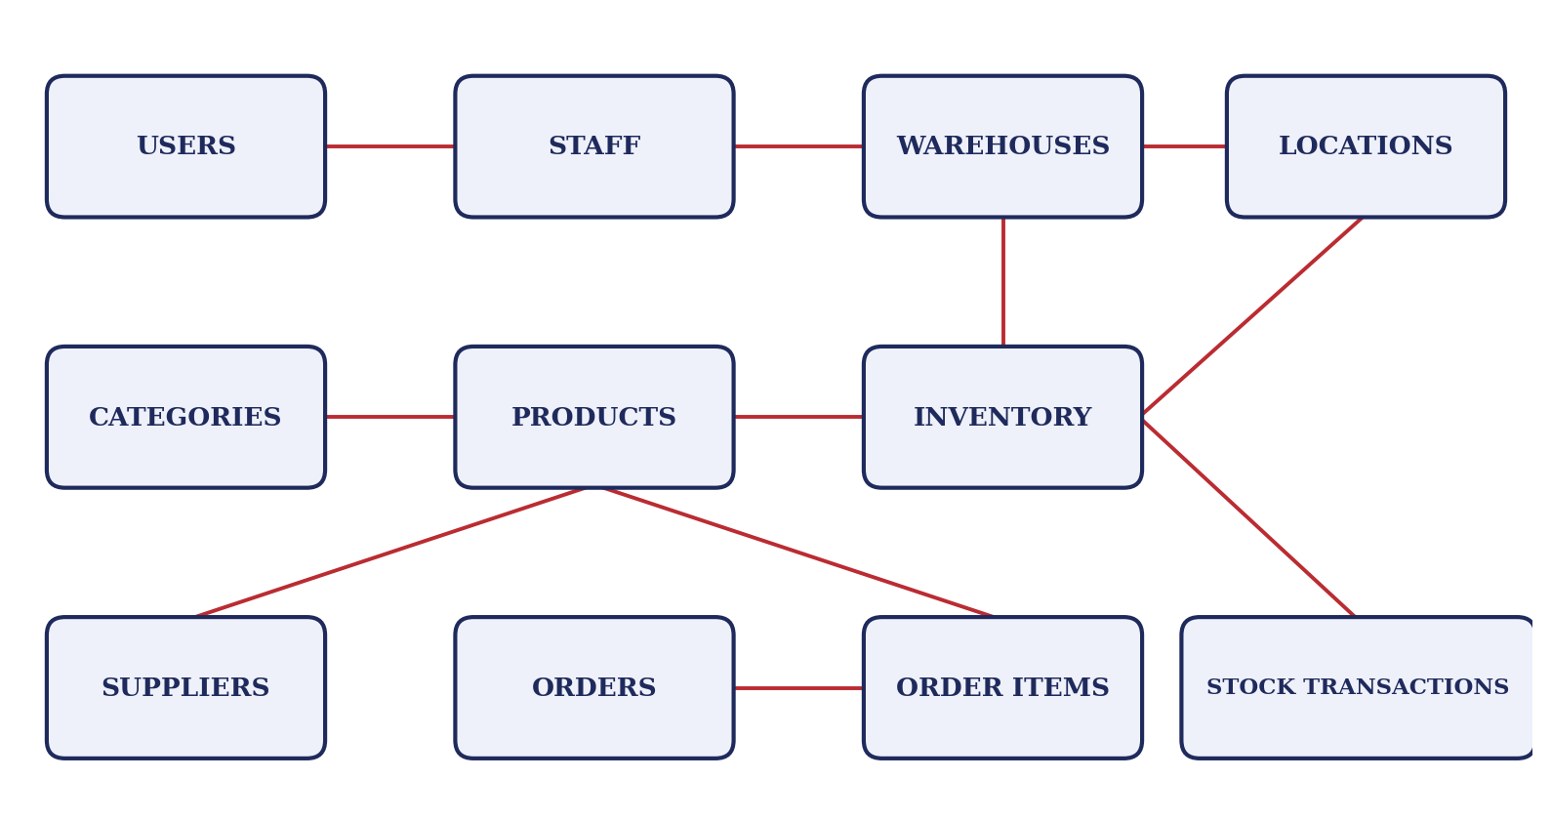
Figure 5.1: Main relationships of the 11-table database
Table | Purpose | Key fields
users | Login accounts and roles | user_id (PK), name, email (UNIQUE), password_hash, role
staff | Staff profile and assigned warehouse | staff_id (PK), user_id (FK), warehouse_id (FK), designation, phone
warehouses | Warehouse master data | warehouse_id (PK), name, address, total_capacity
locations | Storage slots inside a warehouse | location_id (PK), warehouse_id (FK), code, capacity, storage_type, distance_to_dock
categories | Product grouping | category_id (PK), name, description
suppliers | Supplier contact details | supplier_id (PK), name, email, phone, address
products | Product catalogue | product_id (PK), sku (UNIQUE), barcode (UNIQUE), name, category_id (FK), supplier_id (FK), unit_price, reorder_level, storage_type, demand_score
inventory | Quantity of a product at a location | inventory_id (PK), product_id (FK), location_id (FK), quantity (CHECK >= 0)
stock_transactions | History of every stock movement | txn_id (PK), product_id (FK), location_id (FK), type, quantity, performed_by (FK), created_at
orders | Customer orders | order_id (PK), customer_name, status, created_by (FK), order_date
order_items | Products within an order | item_id (PK), order_id (FK), product_id (FK), quantity, unit_price
Table 5.1: Database tables and key fields

5.3 Design Decisions and Assumptions
- Stock ledger: quantities in the inventory table are changed only together with an insert into stock_transactions, inside one database transaction, so the current stock can always be explained by the history.
- Capacity rules: a location accepts stock only while its used quantity stays within its capacity and its storage_type matches the product’s requirement.
- Role-based access: three roles are planned (Administrator, Warehouse Manager, Staff). Staff actions are limited to their assigned warehouse.
- Slotting as a suggestion: the optimization module proposes assignments; a manager reviews and applies them, and every move is recorded as a transaction.
- Assumptions: each location has a known distance from the dispatch dock, and demand is measured from recent order and stock-out history.

CHAPTER 6: IMPLEMENTATION

6.1 Module-wise Implementation
The application is divided into authentication, master data (products, categories, suppliers, warehouses, locations, staff), inventory and stock transactions, orders, barcode lookup, dashboard and reports, and warehouse slotting optimization.
Inventory and stock transactions. For stock-in, stock-out, transfer and adjustment, the backend starts a transaction, locks the affected inventory row with SELECT ... FOR UPDATE, checks that the quantity and location capacity allow the change, updates the inventory row and inserts a stock_transactions record, and then commits. If any step fails, the transaction rolls back. A transfer updates the source and destination rows in the same transaction.
Orders. When an order is created, each order item is checked against available stock and the quantities are deducted using the same transactional stock-out routine. Cancelling an order restores the stock and records the reversal.
Warehouse Slotting Optimization. The module decides where products should be stored so that the most requested products are the easiest to reach. Its steps are shown in Figure 6.1.
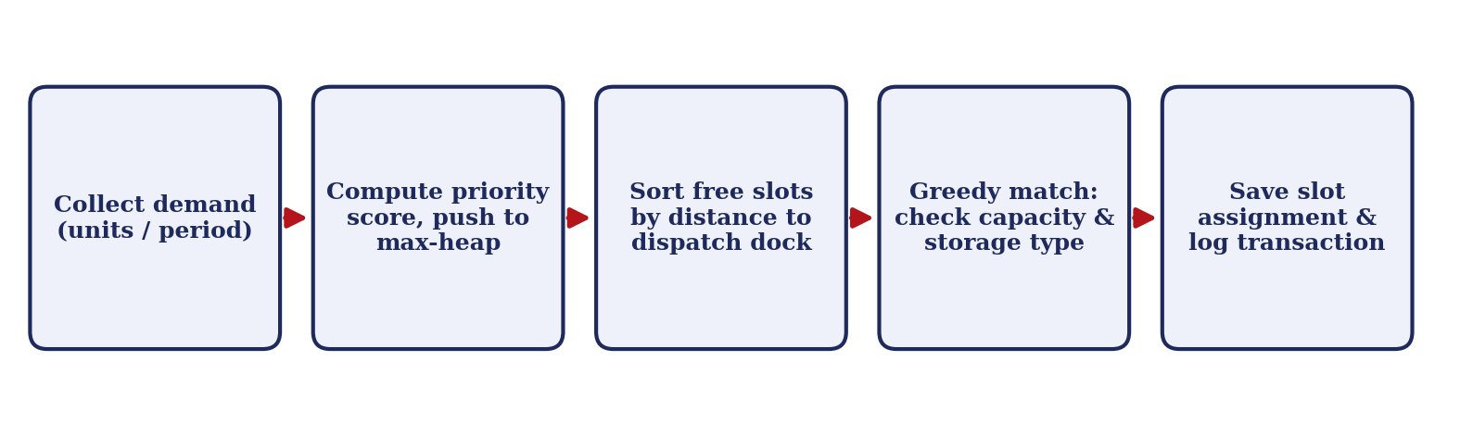
Figure 6.1: Warehouse Slotting Optimization workflow
- Prioritize by demand: each product receives a demand score from its recent units moved and order frequency. Products are placed in a priority queue (max-heap), so the highest-demand product is always taken first.
- Order the locations: free locations are sorted by distance to the dispatch dock, so the most accessible slots come first.
- Greedy assignment: for each product, taken in priority order, the algorithm picks the nearest location that has enough free capacity and the required storage type. It never exceeds capacity and records products that could not be placed.
- Complexity: sorting the products and locations costs O(n log n + m log m) for n products and m locations. Matching costs up to O(n·m) in the worst case if locations are searched linearly, and less if locations are grouped by storage type.
Greedy assignment is fast and easy to explain, but it gives a good solution rather than a guaranteed global optimum; this is discussed in Chapter 10.

6.2 Front-end Logic
React state manages the logged-in user, selected warehouse, form inputs and loaded data. The dashboard shows summary cards (total products, low-stock items, warehouse utilization, pending orders) and Chart.js charts. Product and inventory tables support search, filtering and sorting. Stock-transaction forms validate quantities before submission, and loading, empty and error states help users understand pending requests. The scan screen reads a barcode through the camera and shows the matching product with its stock by location.

6.3 API Integration
The frontend sends JSON requests to the Express API under the /api prefix. Protected requests include the JWT in the Authorization header. The server returns product data, stock levels, transaction results and slotting suggestions, and the interface displays validation errors returned by the backend. A transaction is shown as successful only after the backend reports that the database commit succeeded.

6.4 Authentication and Authorization
Users log in with their email and password. The backend compares the password with the stored hash and returns a signed JWT that carries the user id and role. Middleware verifies the token on every protected route and checks the role: administrators manage users and master data, managers view reports and run slotting, and staff record stock movements and scan products. Staff accounts are linked to a warehouse, and the backend rejects requests for other warehouses. Accounts are created by an administrator; there is no public sign-up.

CHAPTER 7: FEATURES

7.1 List of Main Features
Administrator and manager features:
- Add and edit products, categories and suppliers, including barcode and SKU
- Create warehouses and storage locations with capacity and storage type
- Manage staff accounts and assign staff to warehouses (administrator)
- View products stored in each warehouse and the capacity used
- View dashboard charts and low-stock alerts
- Run Warehouse Slotting Optimization and review the suggested assignments
Warehouse staff features:
- Record stock-in, stock-out, transfer and adjustment transactions
- Scan a barcode to find a product and its stock by location
- Create orders and update order status
- View stock transaction history for the assigned warehouse

7.2 How Each Feature Works
Stock transactions: the user selects a product, location and quantity. The backend locks the inventory row, checks stock and capacity, updates the quantity and writes a transaction record. A rejected request returns a clear message and changes nothing.
Barcode lookup: the user scans or types a code, and the backend returns the product with its stock by warehouse and location, so staff can find where to pick or store it.
Dashboard: the backend aggregates stock, utilization and movement data, and Chart.js displays it as charts that managers can read at a glance.
Slotting optimization: the manager starts the optimization for a warehouse. The system scores products by demand, sorts the free locations by accessibility and proposes assignments using the greedy method. The manager reviews the proposal and applies it, and each move is stored as a transaction.
Screenshots of these screens will be added from the running application:
Screenshot to be added from the running application.

CHAPTER 8: TESTING

8.1 Postman API Testing
Postman can validate the authentication, product, inventory, transaction, order, scan and slotting endpoints. Login returns a JWT that is supplied to protected requests. A complete test flow logs in, creates a product and location, records stock-in, performs a stock-out and a transfer, creates an order and checks the resulting quantities. Invalid input and unauthorized requests should also be tested.

8.2 Integration Testing
Integration testing should verify the full workflow against MySQL: login, master-data setup, stock-in, transfer, order creation and cancellation, barcode lookup and slotting. Database records should be checked after each step. Concurrent stock-out requests for the last units of a product should also be tested. No execution log was available when this report was prepared.

8.3 Tools Used for Testing
- Postman: manual and scripted API testing
- curl (command line): scripted regression testing
- MySQL command-line client or Workbench: direct verification of table contents and constraint behaviour
- Manual browser testing: verifying the React frontend’s behaviour and appearance

8.4 Test Cases and Results
The following cases describe the expected validation results. Actual results are marked Pending until recorded during execution of this project.
# | Test Case | Expected Result | Actual Result
1 | Login with wrong password | 401; login rejected | Pending
2 | Request with expired or missing JWT | 401; access denied | Pending
3 | Staff calls an admin-only route | 403 Forbidden | Pending
4 | Add product with a duplicate SKU | 409; duplicate rejected | Pending
5 | Stock-out above available quantity | Rejected; stock never negative | Pending
6 | Stock-in beyond location capacity | Rejected; capacity respected | Pending
7 | Request a negative quantity | 400; invalid input rejected | Pending
8 | Transfer stock between locations | Both rows updated together | Pending
9 | Transfer fails midway | Rolled back; no partial change | Pending
10 | Two simultaneous stock-outs for the last units | Only one succeeds | Pending
11 | Create an order with enough stock | Order saved; stock reduced | Pending
12 | Cancel an order | Cancelled; stock restored | Pending
13 | Scan a known and an unknown barcode | Product shown / not-found message | Pending
14 | Run slotting optimization | High-demand products get nearest valid slots; no capacity exceeded | Pending

CHAPTER 9: DEPLOYMENT

9.1 Steps to Deploy
The application is planned to run locally for development and demonstration as follows. The folder names follow the planned repository layout and should be updated to match the final repository.
- Load the database: mysql -u root -p < database/schema.sql
- Start the backend: cd backend, npm install, npm start (port 5000)
- Start the frontend: cd frontend, npm install, npm run dev (port 5173)
- Open http://localhost:5173 and log in with the administrator account

9.2 Environment Configuration
Configure backend/.env with PORT, the database host and port, DB_USER, DB_PASSWORD and DB_NAME=inventory_management, plus a private JWT_SECRET. The initial administrator account is created through a setup script using ADMIN_NAME, ADMIN_EMAIL and ADMIN_PASSWORD. Keep actual secrets outside source control.

9.3 Hosting of Frontend and Backend
The project is documented for local demonstration using a React frontend, an Express backend and a MySQL database. A production deployment requires a compiled frontend, an HTTPS API, protected environment configuration and regular database backups. The API base URL and CORS settings must match the hosted frontend.

CHAPTER 10: CHALLENGES & LIMITATIONS

10.1 Issues Faced During Development
- Concurrent stock updates: two users can try to issue the last units of a product at the same moment, which could make stock negative.
- Capacity and storage rules: stock must never exceed a location’s capacity or be placed in an unsuitable storage type.
- Balancing demand and accessibility: the slotting module must trade off product demand, free capacity and distance, and the best slots are limited.
- Barcode input: camera-based scanning depends on lighting, device quality and browser permissions.
- Access control: staff must see and change only data for their own warehouse.

10.2 Solutions Applied
Row-level locking inside database transactions serializes competing stock updates, and CHECK constraints are a final safeguard against negative quantities. Capacity and storage-type checks run in the backend before any update. The slotting module uses a priority queue for demand and a sorted list of locations for accessibility, and skips locations that fail the capacity or type check. Manual barcode or SKU entry is kept as a fallback to scanning. Middleware checks the role and the assigned warehouse on every protected request.

10.3 Current Limitations or Known Bugs
- The greedy slotting method gives a good assignment quickly but does not guarantee the global optimum.
- Demand is estimated from past data and does not predict future demand.
- There is no integration with RFID readers, scanners with dedicated hardware drivers or automated storage equipment.
- Native Android or iOS distribution is outside the current React web implementation.
- Full execution evidence and cloud-deployment results were not available when this report was prepared and should be recorded before final evaluation.

CHAPTER 11: FUTURE ENHANCEMENTS

11.1 Planned Features
- Automatic low-stock alerts and reorder suggestions by email or SMS.
- Demand forecasting from historical order data to improve slotting decisions.
- Password reset and account verification by email.
- A detailed audit log and downloadable PDF or Excel reports.

11.2 Possible Integrations or Optimizations
- Containerizing the application with Docker for a consistent, reproducible deployment.
- Stronger slotting algorithms that also consider picking routes and product affinity.
- RFID or handheld-scanner integration for faster stock counts.
- Caching frequently used reports and optimizing queries as data grows.
- Expanding automated API and concurrency tests, and adding monitoring for failed transactions.

CHAPTER 12: CONCLUSION

12.1 Summary of the Project
The Inventory and Warehouse Management System provides a database-driven approach to running a warehouse. The documented application combines a React frontend, an Express API and an eleven-table MySQL database to support product and supplier management, stock transactions, orders, barcode lookup, dashboard reporting and warehouse slotting optimization.

12.2 What Was Achieved
The project documentation covers secure role-based login, master-data management, transactional stock movement with capacity checks, order handling, barcode lookup, dashboard charts and a slotting module based on sorting, priority queues and a greedy algorithm. The validation plan records expected results; final execution evidence and screenshots should be added after testing the running application.

12.3 Skills Learned
The project develops practical skills in relational database design, REST API development, authentication and role checks, and React component development with Chart.js. It also shows why transactions and row locks matter when several users change stock at once, and how data-structure techniques such as sorting, heaps and greedy methods solve a real warehouse problem. Working as Team 17 helped the members coordinate implementation, documentation and demonstration tasks.

CHAPTER 13: REFERENCES
- React: Official Documentation, https://react.dev
- Chart.js: Official Documentation, https://www.chartjs.org/docs/
- Node.js: Official Documentation, https://nodejs.org/en/docs
- Express.js: Official Documentation, https://expressjs.com
- MySQL 8.0 Reference Manual, https://dev.mysql.com/doc/refman/8.0/en/
- mysql2 (Node.js MySQL driver): npm documentation, https://www.npmjs.com/package/mysql2
- jsonwebtoken: npm documentation, https://www.npmjs.com/package/jsonwebtoken
- bcryptjs: npm documentation, https://www.npmjs.com/package/bcryptjs
- Postman Learning Center, https://learning.postman.com
- MDN Web Docs: JavaScript and Web APIs reference, https://developer.mozilla.org
- T. H. Cormen, C. E. Leiserson, R. L. Rivest and C. Stein, Introduction to Algorithms (sorting, heaps and greedy algorithms).

CHAPTER 14: APPENDICES

Appendix A: Sample Code Snippets
Illustrative greedy slotting routine (JavaScript):
// Highest-demand products get the most accessible valid slot
function assignSlots(products, slots) {
const queue = [...products]
.sort((a, b) => b.demandScore - a.demandScore);
const free = [...slots]
.sort((a, b) => a.distanceToDock - b.distanceToDock);
const plan = [];
for (const p of queue) {
const i = free.findIndex(s =>
s.freeCapacity >= p.unitsToStore &&
s.storageType === p.storageType);
if (i === -1) {
plan.push({ productId: p.id, slotId: null });
continue;
}
plan.push({ productId: p.id, slotId: free[i].id });
free[i].freeCapacity -= p.unitsToStore;
if (free[i].freeCapacity === 0) free.splice(i, 1);
}
return plan;
}
Illustrative transaction for issuing stock (SQL):
START TRANSACTION;
SELECT quantity FROM inventory
WHERE product_id = ? AND location_id = ? FOR UPDATE;
-- Check that quantity >= requested before updating.
UPDATE inventory SET quantity = quantity - ?
WHERE product_id = ? AND location_id = ? AND quantity >= ?;
INSERT INTO stock_transactions
(product_id, location_id, type, quantity, performed_by)
VALUES (?, ?, 'OUT', ?, ?);
COMMIT;

Appendix B: Installation and Setup Instructions
- mysql -u root -p < database/schema.sql
- cd backend && npm run seed && npm run setup:admin
- cd backend && npm install && npm start (backend, port 5000)
- cd frontend && npm install && npm run dev (frontend, port 5173)
- Open http://localhost:5173 in a browser
Script names follow the planned project layout and should be adjusted to match the final repository.

Appendix C: Default Login Credentials
Role | How the account is created
Administrator | Configured through backend/.env and the admin setup script
Warehouse Manager | Created by the administrator from the Users screen
Staff | Created by the administrator and assigned to a warehouse
Password | Chosen at account creation and stored as a hash
No fixed shared login is required; credentials are never stored in the source code.

Appendix D: API Reference Summary
API resources cover authentication, master data, inventory, orders, scanning, reports and slotting. The backend uses the /api prefix.
Resource | Endpoints
Auth | Login and current-user access
Products | List, search, create, edit and delete products and categories
Suppliers | List, create and edit suppliers
Warehouses | Manage warehouses and storage locations; view stored products and capacity
Inventory | View stock by product, warehouse and location
Transactions | Record stock-in, stock-out, transfer and adjustment; view history
Orders | Create, list, update status and cancel orders
Scan | Look up a product by barcode or SKU
Reports | Dashboard summaries and chart data
Slotting | Generate and apply slotting suggestions

Appendix E: Screenshots
Screenshots are to be added from the running application.
1. Login Page
Screenshot to be added from the running application.

2. Dashboard
Screenshot to be added from the running application.

3. Product and Supplier Management
Screenshot to be added from the running application.

4. Warehouse and Location Capacity View
Screenshot to be added from the running application.

5. Stock Transactions
Screenshot to be added from the running application.

6. Order Management
Screenshot to be added from the running application.

7. Barcode Scan Page
Screenshot to be added from the running application.

8. Warehouse Slotting Optimization Result
Screenshot to be added from the running application.

